
NAME : MAINA RACHAEL WANJIRU
REG NO:BSCCS/2025/34548
Ethical hacking

Contents
WEEK ONE 2
Ethical hacking 2
WEEK TWO 4
Scanning report 4
Ping scanning 4
ip scanning 5
Ip address 7
WEEK THREE 7
Technologies running 8
Email patterns 9
LESSONS LEARNT 9

WEEK ONE

Ethical hacking
The installation process
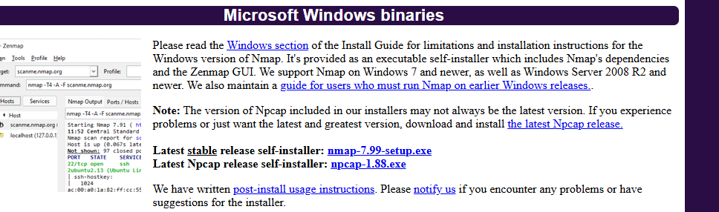

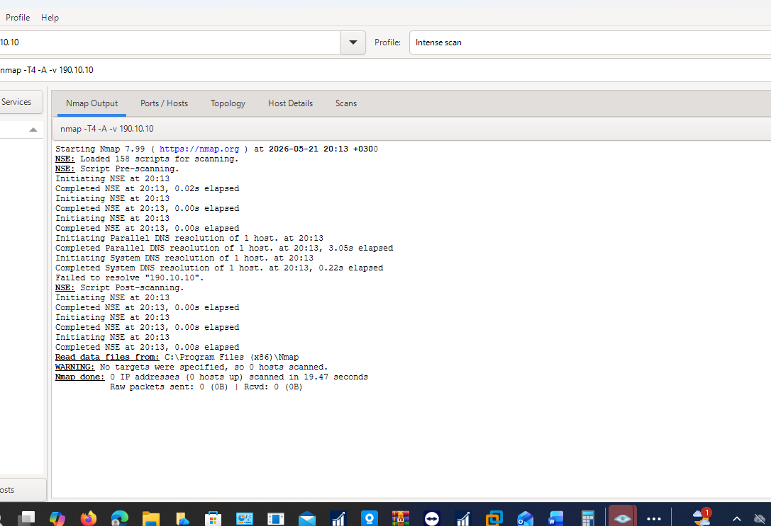

WEEK TWO

Scanning report

Ping scanning
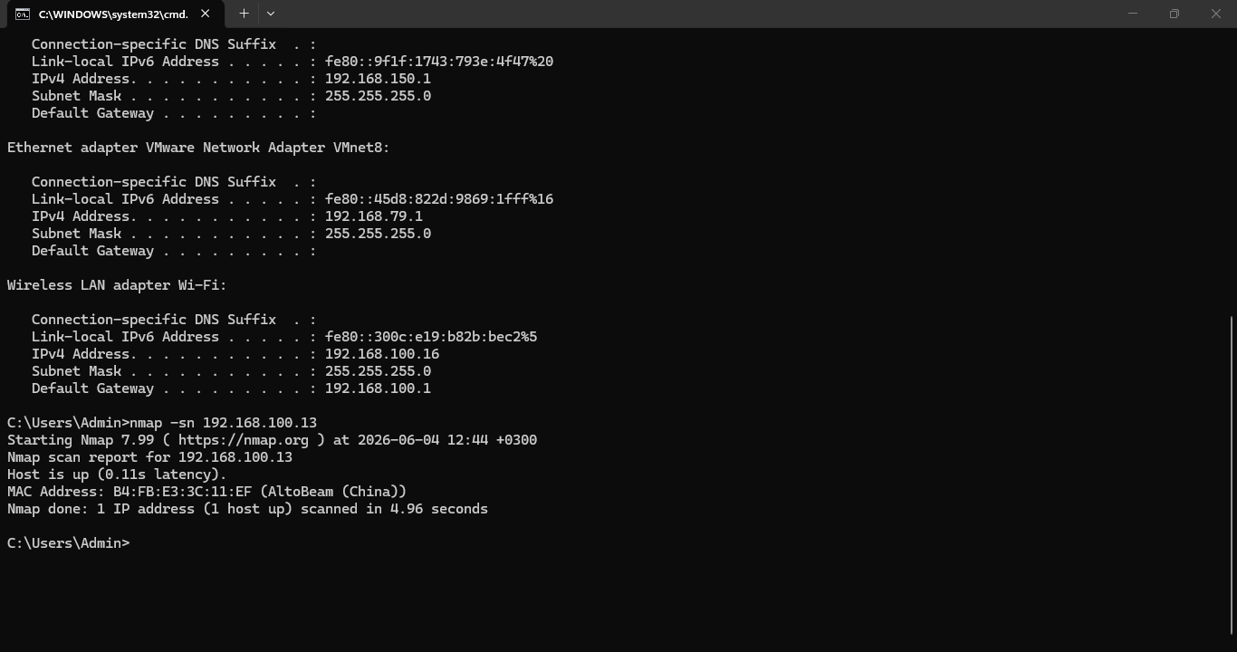
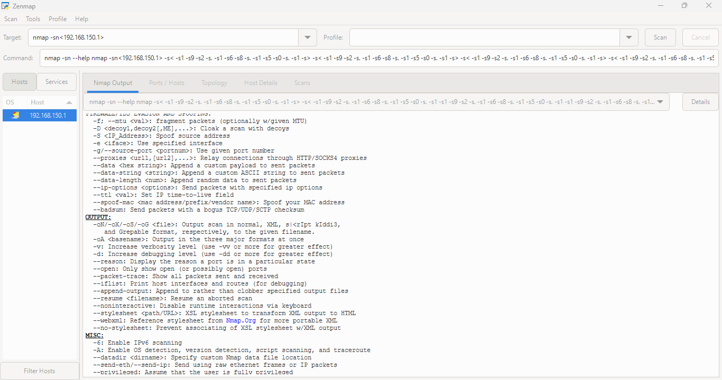

ip scanning
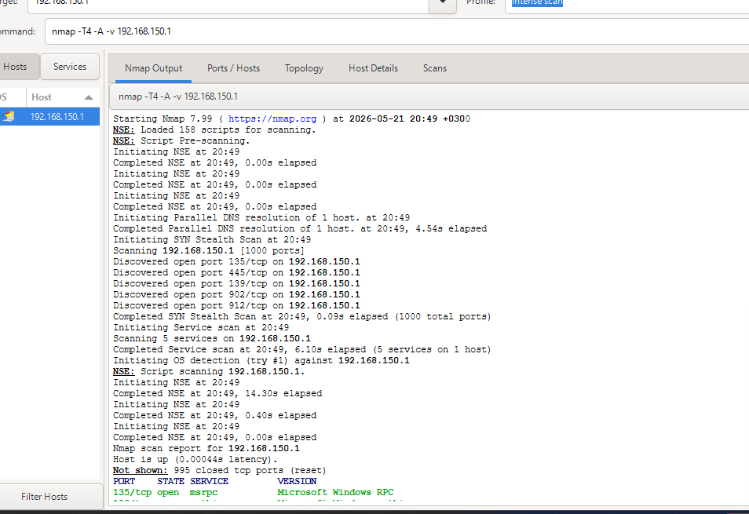

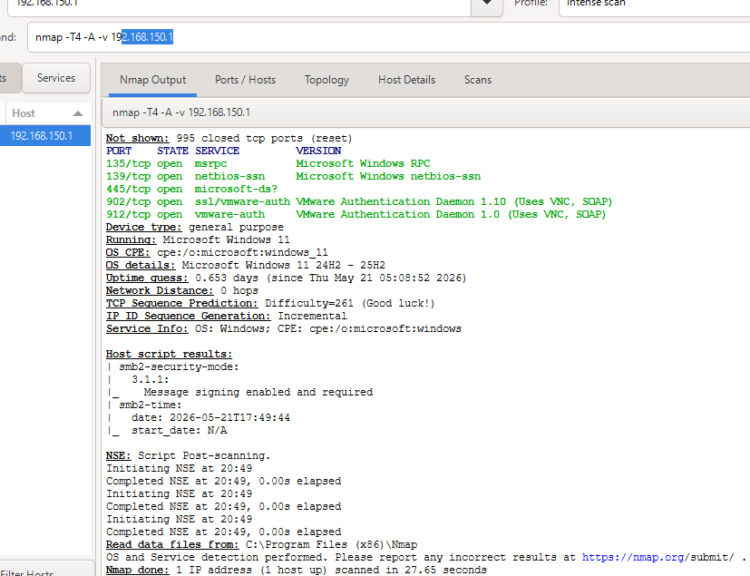

Ip address
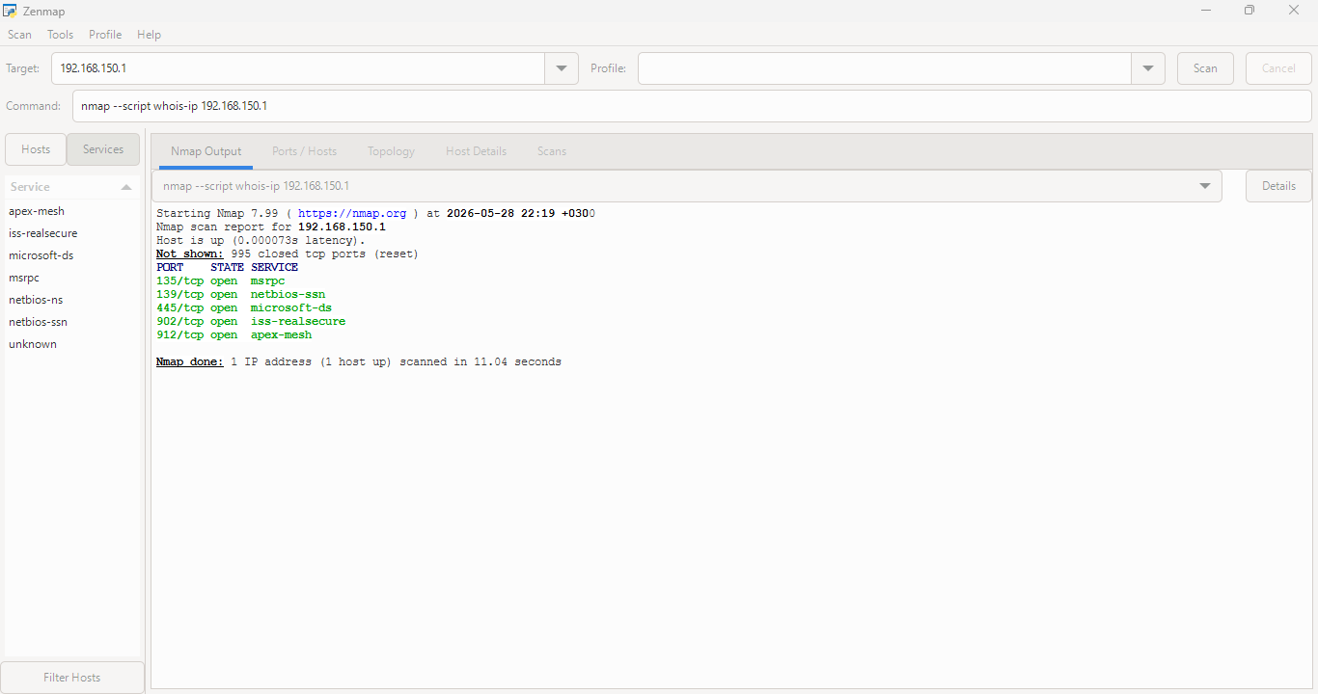

WEEK THREE
  - Ip address ,domain registrar of a company domain
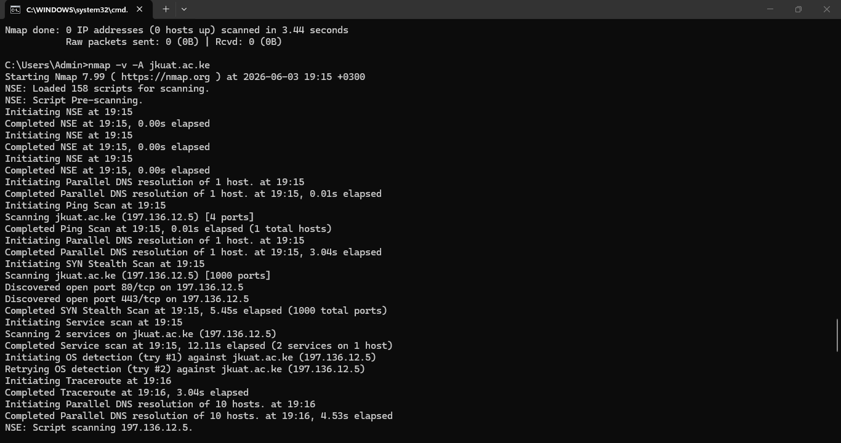
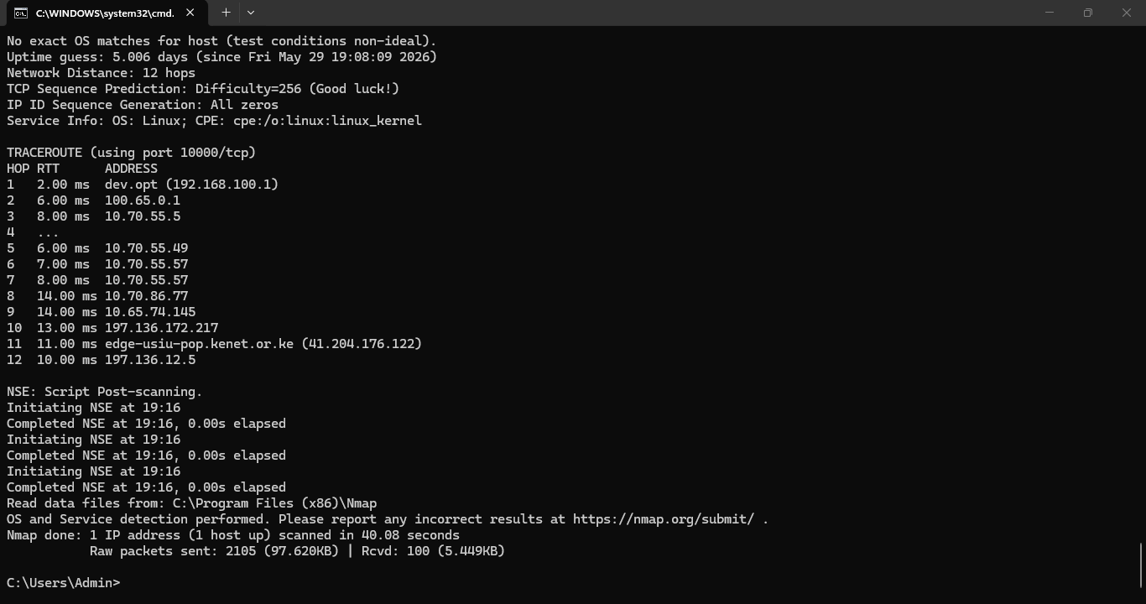

Technologies running
Its secure so no access allowed
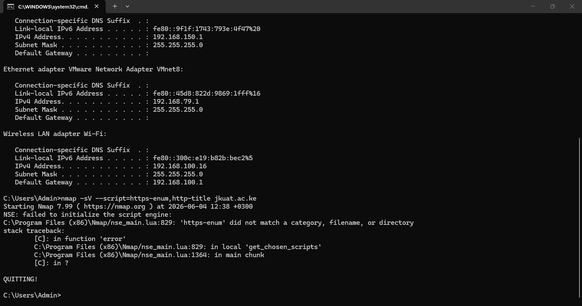

Email patterns
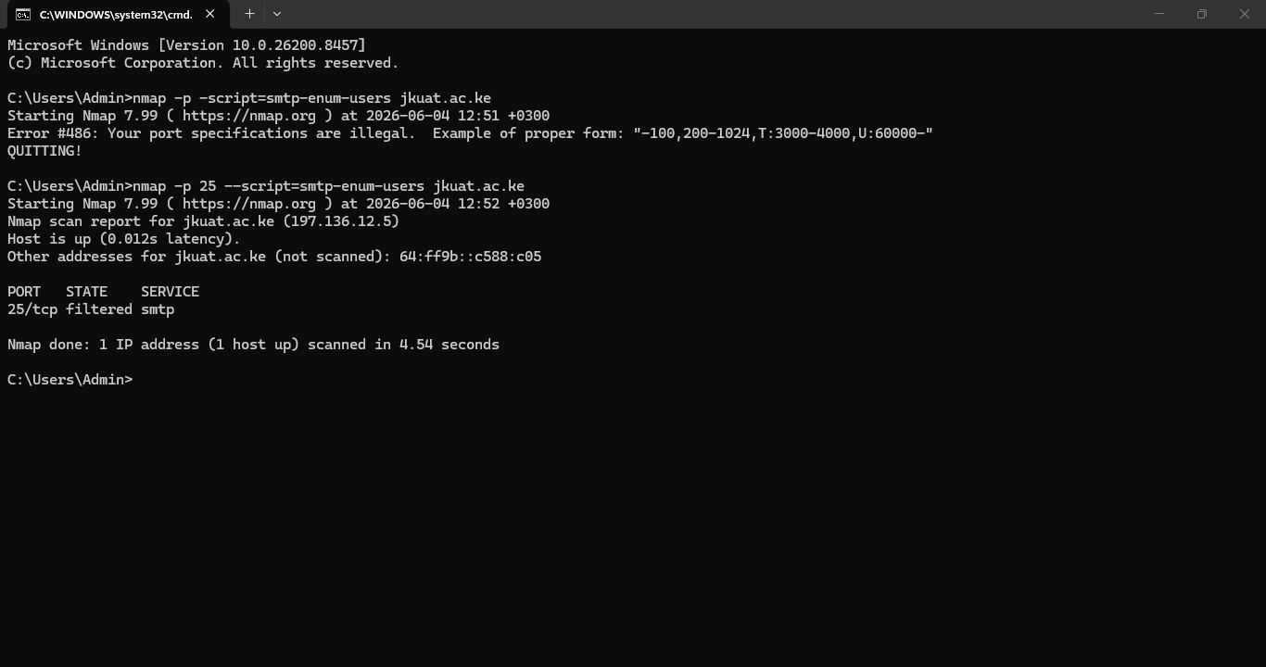

LESSONS LEARNT
There was os detection
No technology found since access was not allowed

